

Student Id : NP03A190051

Student Name : Rishab Sharma

Section : L5CG7

Lecturer : Jnaneshwor Bohara

Module Leader : Hiran Patel

Submitted on : 22nd September, 2021

[Workshop Report-2]

1. Write a multithreaded C program to print out all the prime numbers between 1 to 10000. Use exactly 3 threads.

=> #include <stdio.h>

#include <stdlib.h>

#include <pthread.h>

void *printPrimeNumbers() {

int flag, i, j;

for(i=1; i<=10000; i++) {

flag = 1;

if(i==1 || i==0) {

continue;

}

for (j = 2; j <= i/2; j++) {

if(i % j == 0) {

flag = 0;

break;

}

}

if(flag == 1) {

printf("%d\n", i);

}

}

}

int main() {

int n;

pthread_t thread_id;

printf("Enter the number of threads u want to use: ");

scanf("%d", &n);

int i;

for(i = 0; i < n; i++) {

pthread_create(&thread_id, NULL, printPrimeNumbers, &thread_id);

pthread_join(thread_id, NULL);

}

exit(0);

}

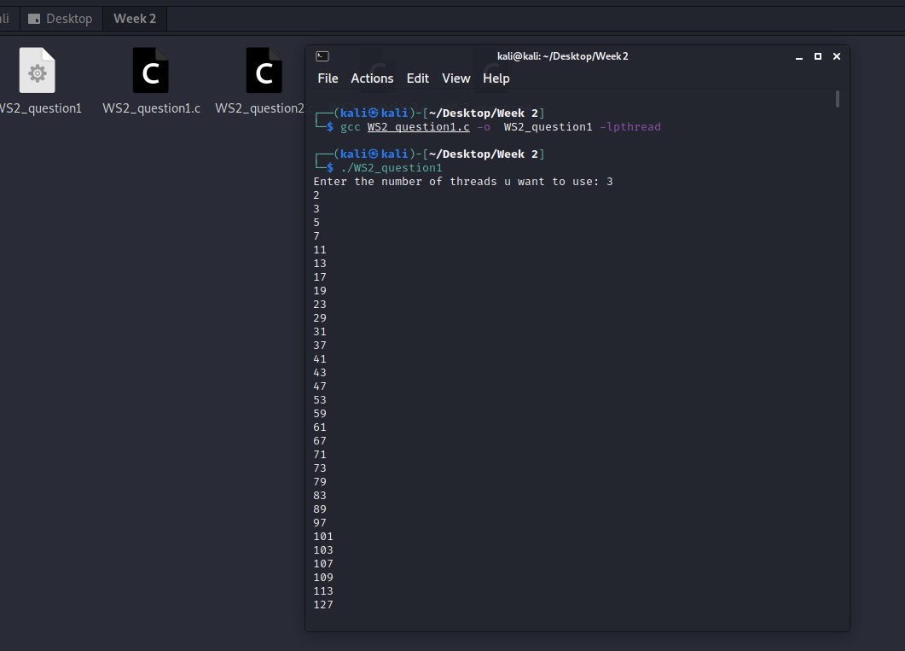

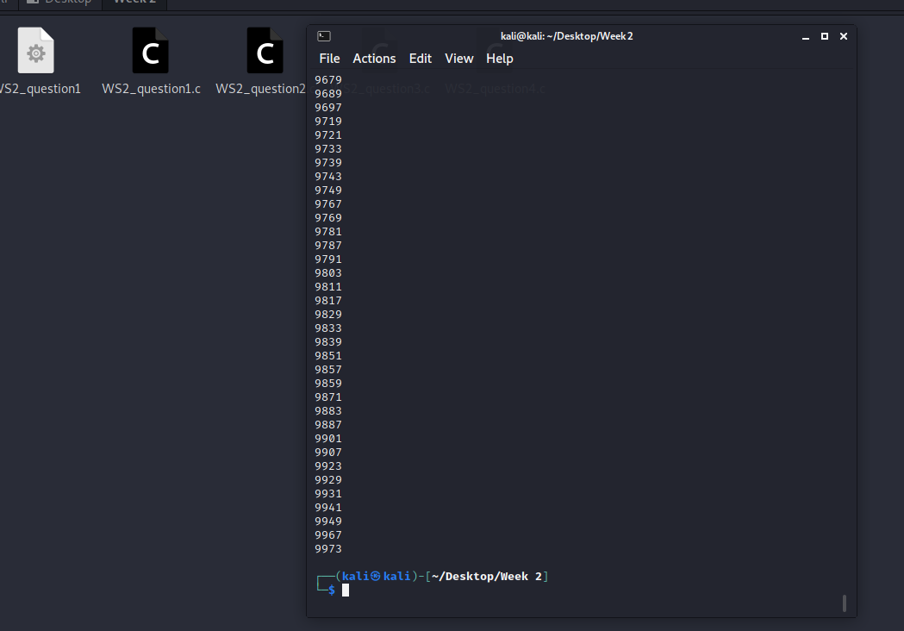

1. Convert this program to prompt the user for a number and then to create the number of threads the user has specified to find the prime numbers.

=> #include <stdio.h>

#include <stdlib.h>

#include <pthread.h>

void *printPrimeNumbers() {

int flag, i, j;

for(i=1; i<=10000; i++) {

flag = 1;

if(i==1 || i==0) {

continue;

}

for (j = 2; j <= i/2; j++) {

if(i % j == 0) {

flag = 0;

break;

}

}

if(flag == 1) {

printf("%d\n", i);

}

}

}

int main() {

int n;

pthread_t thread_id;

printf("Enter the number of threads u want to use: ");

scanf("%d", &n);

int i;

for(i = 0; i < n; i++) {

pthread_create(&thread_id, NULL, printPrimeNumbers, &thread_id);

pthread_join(thread_id, NULL);

}

exit(0);

}

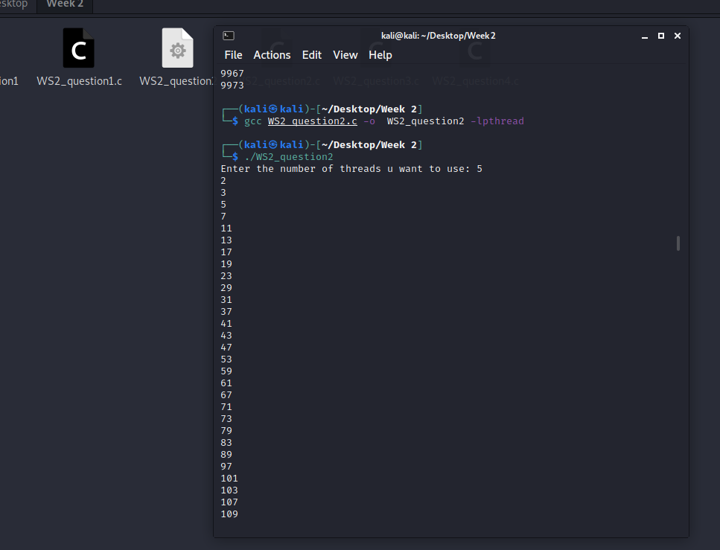

1. Convert the program in (2) so that each thread returns the number of prime numbers that it has found using pthread_exit() and for main program to print out the number of prime number that each thread has found.

=> #include<stdio.h>

#include<stdlib.h>

#include<pthread.h>

typedef struct{

int start;

int end;

}

range;

void *prime(void *ptr)

{

int i,c;

int *counter;

counter = malloc(sizeof(int));

int counts = 0;

range *p = ptr;

int nstart=p->start, nend=p->end;

for(i=nstart; i<=nend; i++){

for(c=2; c<=i-1; c++) {

if ( i%c==0 ) {

break;

}

}

if ( c==i ) {

counts = counts + 1;

}

}

*counter = counts;

pthread_exit(counter);

}

void main(){

void *pointer;

int count = 1000;

int thread;

printf("Number of threads:");

scanf("%d", &thread);

int sliceList[thread]; //3 slice boxes

int rem = count % thread;

for (int i =0; i<thread; i++){

sliceList[i] = count / thread;

}

// equally distribute the remainders in each thread

for(int j = 0; j<rem; j++){

sliceList[j] = sliceList[j] + 1;

}

int startList[thread];

int endList[thread];

// start = 0

// end = 3333

for(int l = 0 ;l < thread; l++){

// if it is the start

if(l == 0){

startList[l] = 0;

}

// endList[1 -1] = 0 which is starting index gets the endlist value + 1

else{

startList[l] = endList[l-1] + 1;

}

endList[l] = startList[l] + sliceList[l] -1; //3334+3333-1 -> 6666

}

range nums[thread];

for(int k = 0; k< thread; k++){

nums[k].start = startList[k];

nums[k].end = endList[k];

}

// create thread according to nummber of thread by user

pthread_t threadIDs[thread];

for(int n = 0; n<thread; n++){

pthread_create(&threadIDs[n], NULL, prime, &nums[n]);

}

for(int n = 0; n<thread; n++){

pthread_join(threadIDs[n],&pointer);

printf("prime number thread %d = %d\n",n+1,*(int*)pointer);

}

}

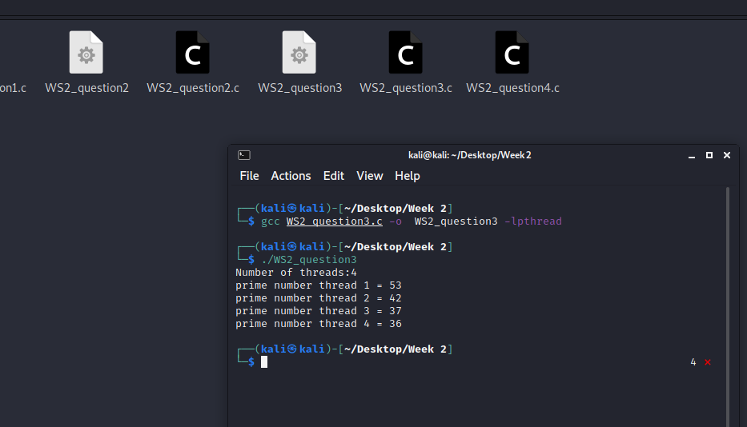

1. Convert the program in (3) to use pthread_cancel() to cancel all threads as soon as the 5th prime number has been found.

=> #include<stdio.h>

#include<pthread.h>

#include<stdlib.h>

int counter=0;

typedef struct{

int start;

int end;

}count;

void *countPrime(void *p){

count *parameter;

parameter = (count *)p;

int start = parameter->start;

int end = parameter->end;

int i,c;

for(i=start;i<end;i++){

for(c=2;c<=i-1;c++){

if(i%c==0){

break;

}

}

if (counter >= 5)

{

pthread_cancel(pthread_self());

}

if(c == i){

counter+=1;

printf("%d is prime.\n",i);

}

}

}

void main()

{

int n,i;

printf("Enter number of threads:");

scanf("%d",&n);

pthread_t thread[n];

count range[n];

int split = 1000/n;

for(i=0;i<n;i++){

if(i==0){

range[i].start = 1;

range[i].end = split;

}

else{

range[i].start = range[i-1].end + 1;

range[i].end = range[i-1].end + split;

}

}

for ( i = 0; i < n; i++)

{

pthread_create(&thread[i],NULL,countPrime,(void *)&range[i]);

}

for ( i = 0; i < n; i++)

{

pthread_join(thread[i],NULL);

}

printf("Total prime:%d",counter);

}

